Sean McGuire

**Gesture based UI project**

GitHub: <https://github.com/smcguire56/GestureBasedUIProject>

For my project I will be using the Myo Armband to develop a real-life driving experience in a unity game. The game will be developed in unity and coded in C# and will be focused mostly on the first person steering of a car going around a simple 3D track. At the end of the project I will aim to get the Myo Armband to connect to the game as a user gesture-based control for various gestures such as steering the car, changing gear, and pausing the game.

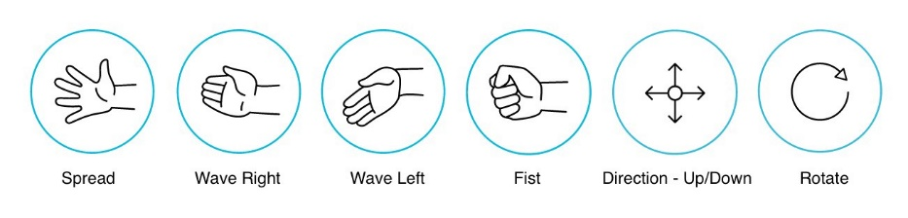

From the image above these are some of the primitive gestures the armband can provide and through further research I will aim to apply some if not all these gestures for my game.

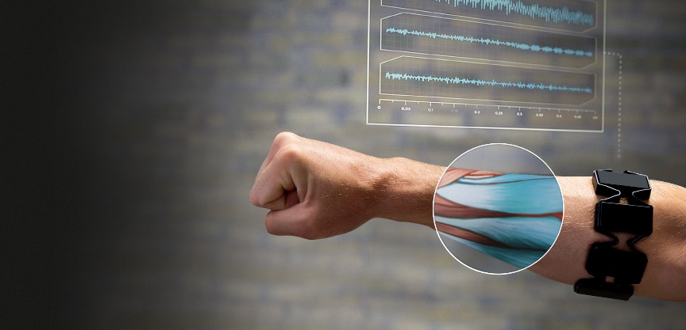

The Myo armband works by using many sensors to detect small changes in the muscles it is in contact with. Using these sensors, the software can take in the raw input from 8 of the sensors and graph the changes to time. For my project in gesture-based UI I can use these inputs to make the user believe they are driving a car in this game and hopefully make it feel as realistic as possible.

The software and languages I will be using for this project are Unity and C#.

For tracking my progress throughout the project, I will be using GitHub.

* What I’ve got so far:
  + The game is now converted to just drag racing mode now as I am only testing one of the features for double tap.
  + The UI allows the user to double tap their fingers in game to change the gear and make the car go faster.
  + The terrain in the game is in 3D.
  + The AI other driver is set currently to a max speed, will change later.
  + At the moment the car can either win the game or lose.

Update:

I’ve got 2 different gestures working now, the double tap still working for the change gear mechanic and now there is a boost function when user clenches fist.

This allows the user to gain a more advantage.

Gestures:

Before the game starts, there is a splash screen describing the various gestures the user can use:

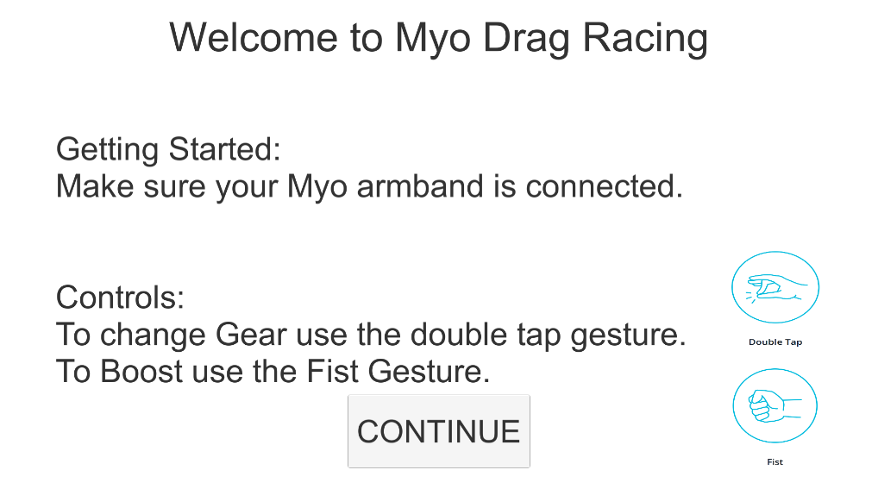

Since this game is a drag racing game, the player only goes in a straight line, knowing when to change the gear and apply the Boost is key in order to get a good time.

The reason behind choosing the double tap gesture is it is the most recognizable gesture that the myo sdk can pick up. After some testing, personally the 2 easiest gestures to recreate at a rapid time movement are the Double tap and the Fist. Changing the gear at the right time is key to winning the game and I required an action the user could recreate many times and could be detected very easily.

The boost function allows the car to travel at a 2x speed difference to the previous speed allowing the car to move at a more rapid speed. This is done by initially lowering the default traction control in the 2 cars (the players and ai’s car) and setting the traction back to a higher value after the user applies the boost gesture.